Michael Sanchez
CS-405
1/29/26
Michael’s Exceptions
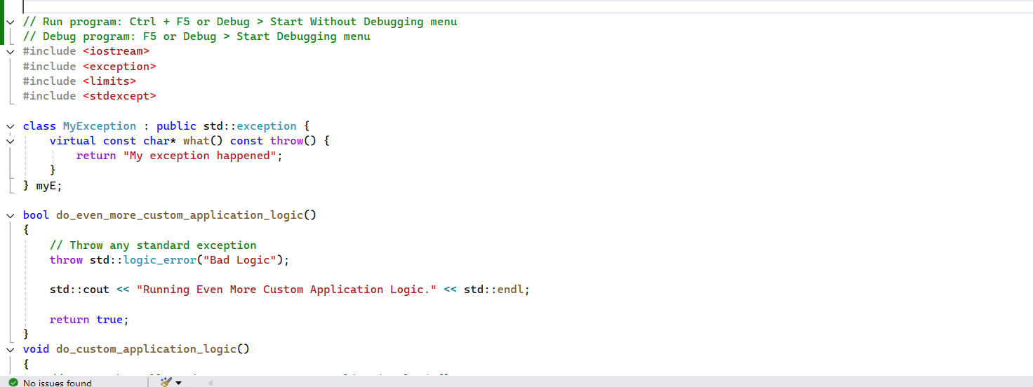
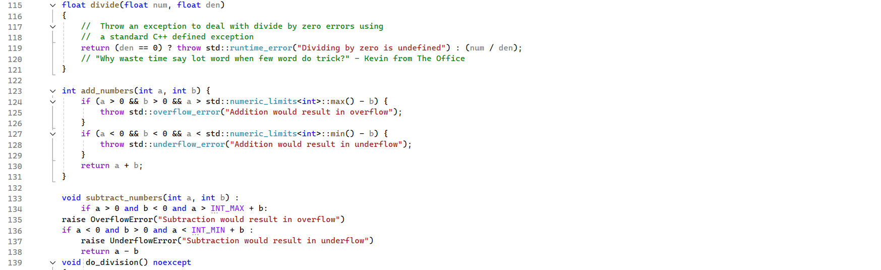
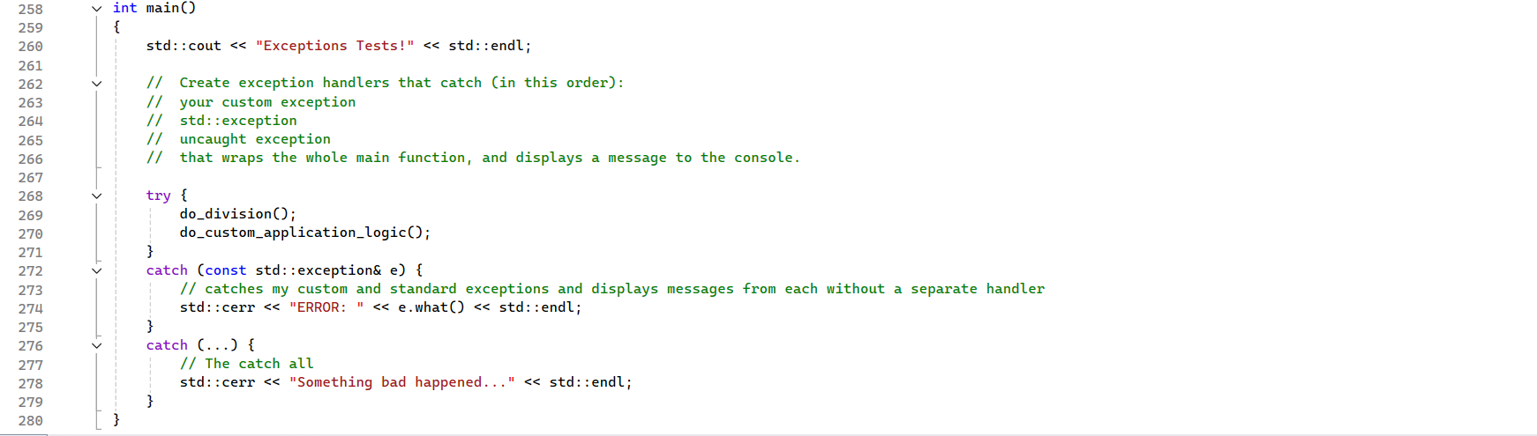
Software developers working on a banking web application found code that crashes without warning. Instead of changing it, they decided to oversee errors by displaying messages to users. Developers want to use exception handling: wrap risky code in a try-block, catch exceptions derived from std::exception, manage unhandled exceptions, throw standard C++ exceptions, and create and manage custom exceptions (but avoid non-std::exception types). Using the C++ standard library for support. Data changes affecting customers can be evaluated with a value matrix algorithm to guide improvements and fulfill bank obligations. Modified data in the code demonstrates how smart contracts can impact customer bank accounts. These changes enable both employees and customers to manage data more efficiently, making significant improvements to banking systems.

